LINE GRAPH
The graph below shows average carbon dioxide (CO2) emissions per person in the United Kingdom, Sweden, Italy and Portugal between 1967 and 2007.
Summarise the information by selecting and reporting the main features, making comparisons where relevant.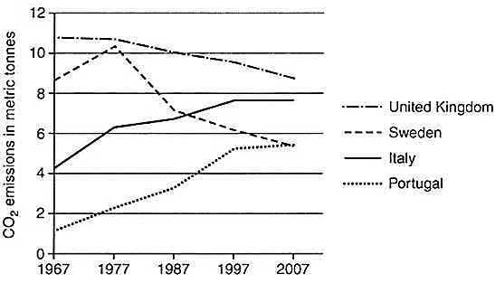
BAR GRAPH
The chart below shows the results of a survey about people’s coffee and tea buying and drinking habits in five Australian cities.
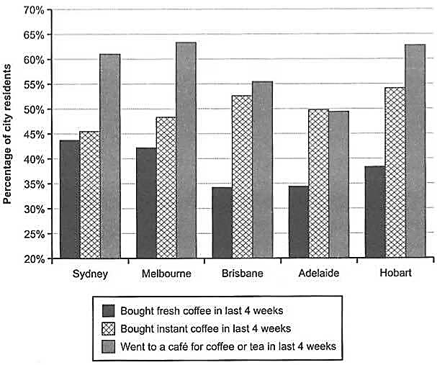
PIE CHART
The charts below show the percentage of water used for different purposes in six areas of the world.

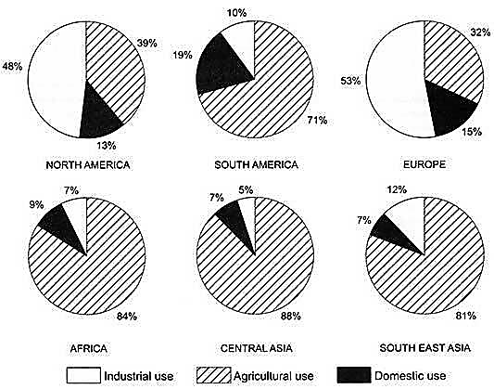

TABLE
The Table Below Gives Information on Consumer Spending on Different Items in Five Different Countries in 2002

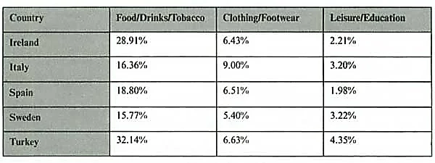
MAP
The two maps below show road access to a city hospital in 2007 and in 2010.
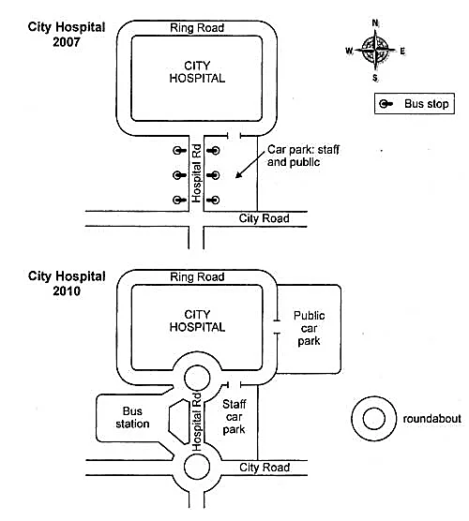
PROCESS DIAGRAM
The diagram below shows the process for recycling plastic bottles.
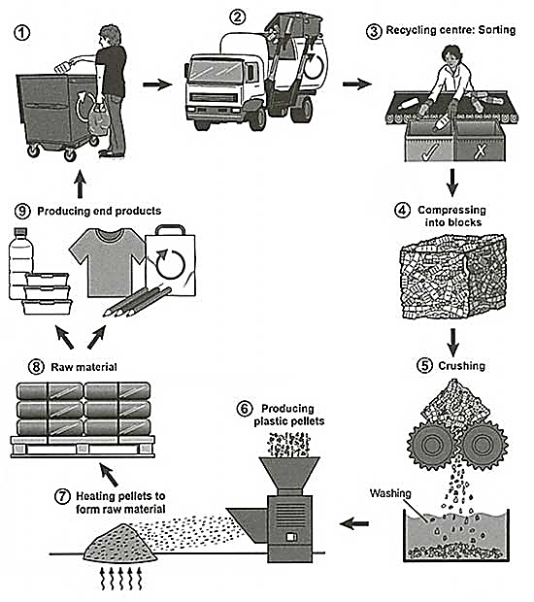
TWO DATA TOGETHER
The graph and table below give information about water use worldwide and water consumption in two different countries.
